ABSTRACT

The IoT Based Water Purity Testing System is designed to provide real-time, accurate, and continuous monitoring of water quality parameters to ensure safe consumption and early detection of contamination. Traditional water quality testing relies on manual sample collection and delayed laboratory analysis, which is inefficient for real-time monitoring. The proposed system uses an ESP32 microcontroller integrated with multiple sensors, including a pH sensor, Turbidity sensor, Total Dissolved Solids (TDS) sensor, and DS18B20 temperature sensor. The microcontroller acquires analog signals from these sensors, processes the values, and transmits the live data wirelessly to an IoT cloud platform (such as Blynk or ThingSpeak). When parameters cross safe WHO thresholds, an alert signal (buzzer/LED) is activated locally, and remote notifications are triggered. The proposed system can be deployed in municipal water supplies, industrial effluent treatment plants, aquaculture farms, residential complexes, and smart city environments to enhance public health and automate water quality management.

INTRODUCTION

Water is one of the most essential natural resources required for human survival, agriculture, and industry. However, industrialization, agricultural runoff, and inadequate waste disposal have severely compromised water quality worldwide. Consuming contaminated water leads to severe health risks, including waterborne diseases like cholera, typhoid, and dysentery.
Traditional water testing methods involve collecting physical samples from various water sources and sending them to centralized laboratories for chemical and biological evaluation. While accurate, this process is time-consuming, expensive, and incapable of providing real-time alerts when sudden contamination occurs.
To overcome these challenges, the IoT Based Water Purity Testing System leverages Internet of Things (IoT) technology and embedded microcontrollers to deliver continuous online monitoring. Powered by an ESP32 microcontroller, the system reads physical and chemical characteristics using pH, turbidity, TDS, and temperature sensors. Data is processed locally and uploaded wirelessly to cloud servers, enabling users and authorities to monitor water parameters remotely via smartphones or web dashboards in real time.

NEED OF THE PROJECT

Immediate Contamination Detection: Conventional testing fails to catch sudden chemical spills or pipe breakdowns immediately; an automated IoT system detects anomalies instantly.
Public Health Safety: Drinking water supplies must strictly adhere to World Health Organization (WHO) safety standards. Continuous pH and TDS tracking ensures water safe for human consumption.
Automated Data Logging: Eliminates manual human errors in recording physical measurements and creates a digital database for long-term trend analysis.
Remote Accessibility: Field officers, municipal engineers, and residential users can check water quality from anywhere via a mobile app or web platform without physical presence.

PROBLEM STATEMENT

Existing water quality monitoring relies heavily on periodic manual sampling and laboratory testing, which suffers from low sampling frequency, high operational costs, and significant delays between sample collection and result generation. During sudden contamination events (such as industrial waste leakage or pipe rust leaching), consumers may ingest unsafe water before lab results are processed. Additionally, existing portable meters require manual operation on-site and lack automated cloud telemetry or threshold alerts. Therefore, there is a strong need for an autonomous, low-cost, real-time IoT-based system capable of continuously measuring key water quality parameters and issuing instant alerts.

OBJECTIVES

The main objective of this project is to develop an IoT-based smart water purity monitoring system using an ESP32 microcontroller and multi-sensor telemetry to evaluate water health continuously.

TO SPECIFIC OBJECTIVES

Interface pH, Turbidity, TDS, and Temperature (DS18B20) sensors with the ESP32 microcontroller.
Program the ESP32 using C++/Arduino IDE to perform ADC conversion, sensor calibration, and data processing.
Configure Wi-Fi connectivity on the ESP32 to upload sensor readings to an IoT cloud platform (Blynk / ThingSpeak) at periodic intervals.
Display real-time water quality metrics on a physical LCD display and a virtual cloud mobile application dashboard.
Implement threshold-based logic to activate local buzzer alarms and send cloud notifications when water quality drops below safe levels.
Test and validate system accuracy using different water samples (tap water, purified water, muddy water, and saline solutions).

HARDWARE REQUIREMENTS

ESP32 Development Board: Microcontroller with built-in Wi-Fi/Bluetooth and analog-to-digital converters (ADC) for main processing and cloud communication.
pH Sensor Module: Measures the acidity or alkalinity level of the water solution (pH range 0–14).
Turbidity Sensor Module: Measures water clarity by emitting light and evaluating light scattering caused by suspended solids.
TDS Sensor Module (Total Dissolved Solids): Measures the concentration of dissolved inorganic salts and minerals in PPM (parts per million).
DS18B20 Temperature Sensor: Waterproof digital sensor for measuring water temperature to compensate temperature-dependent TDS/pH calculations.
16x2 I2C LCD Display: Displays real-time sensor parameters on-site.
Buzzer & Indicator LEDs: Provides audible and visual alarms during critical contamination events.
Power Supply Unit (5V/3.3V): Powers the ESP32 board and sensor modules.
Connecting Wires & Breadboard: For prototyping hardware connections.

SOFTWARE REQUIREMENTS

Arduino IDE: Used for writing, compiling, and uploading C++ firmware to the ESP32 board.
Embedded C++: Programming language used to develop control algorithms, sensor sampling routines, and data processing algorithms.
Blynk / ThingSpeak Cloud Platform: IoT platform used for hosting real-time dashboards, historical data charting, and alert notification triggers.
ThingSpeak API / MQTT Protocols: Communication protocols used for data transmission between ESP32 and cloud servers.

EXISTING SYSTEM

Existing water quality monitoring systems primarily fall into two categories: standard laboratory chemical testing and standalone handheld meters (such as digital pH pens or TDS probes). Standard testing requires taking water samples directly to a lab, using chemical reagents, and waiting up to several days for a detailed report. Handheld meters allow on-site testing, but require a technician to physically submerge probes and manually record readings.

LIMITATIONS OF EXISTING SYSTEM

• No Real-Time Telemetry: Requires physical presence; cannot monitor water quality continuously 24/7.
• Delayed Response: Lab testing delay prevents immediate action during chemical leakages.
• High Labor Cost: Manual collection across wide distribution networks incurs high operational costs.
• Lack of Historical Cloud Storage: Standalone meters lack automated data logging for predictive maintenance.
• No Automated Emergency Alerts: Existing systems do not automatically trigger alerts to consumers or engineers when safe limits are breached.

PROPOSED SYSTEM

The proposed system is an IoT Based Water Purity Testing System engineered around the ESP32 microcontroller. The system continuously samples water using four dedicated sensors: pH, Turbidity, TDS, and Temperature.
The raw analog outputs from the sensors are acquired by the ESP32's ADC channels, filtered through software algorithms, and converted into standard units ($\text{pH}$, $\text{NTU}$, $\text{PPM}$, and $\text{^circC}$). The processed data is displayed locally on a $16×2$ I2C LCD and transmitted wirelessly over Wi-Fi to an IoT cloud server (Blynk/ThingSpeak) using MQTT/HTTP protocols. If any measured parameter exceeds predefined safety thresholds (e.g., $\text{pH}<6.5$, $\text{pH}>8.5$, or $\text{TDS}>500\text{ PPM}$), the system activates a local buzzer and pushes immediate notifications to mobile devices.

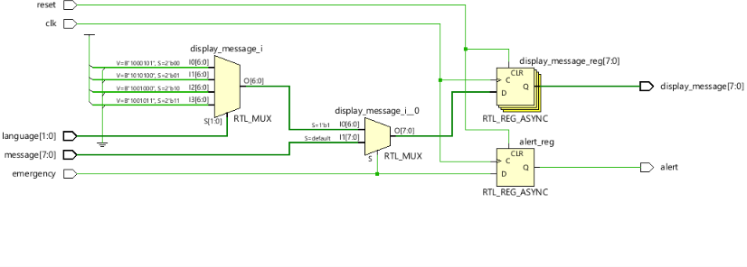
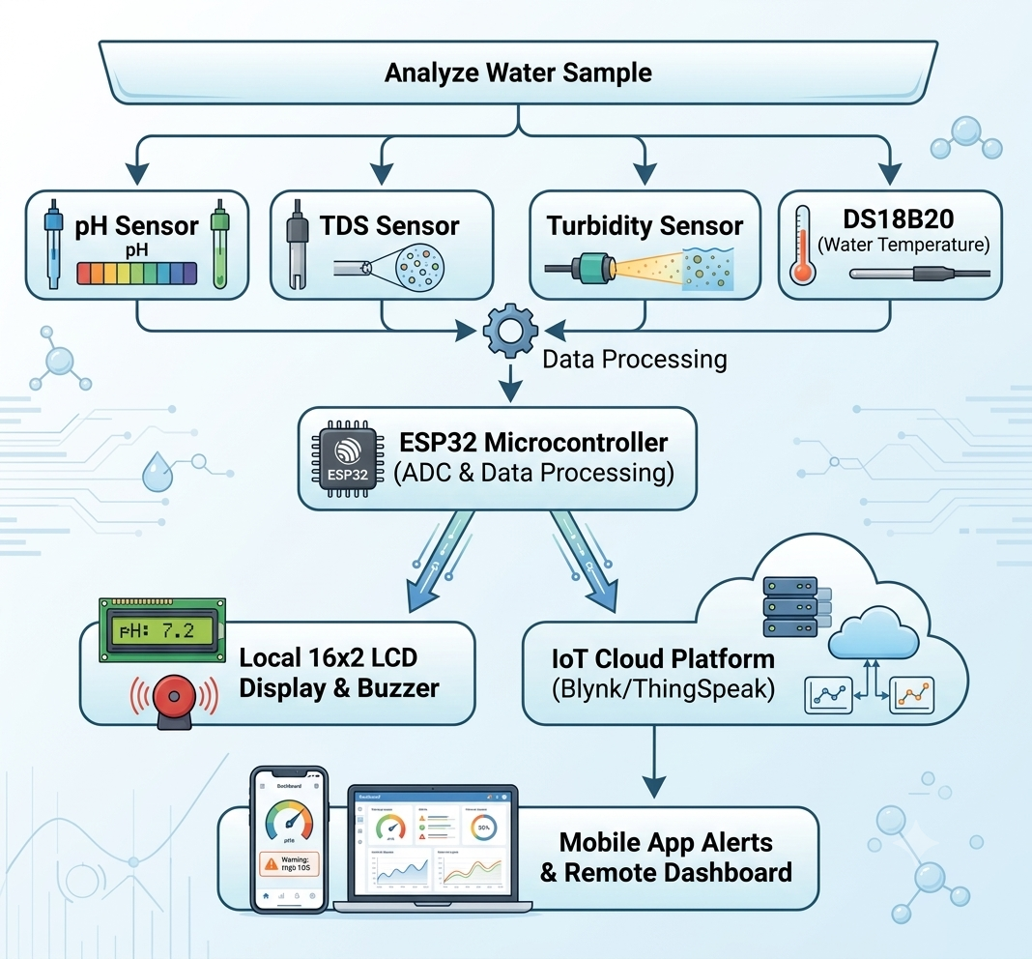

FEATURES OF THE PROPOSED SYSTEM

• Multi-Parameter Monitoring: Evaluates pH, Turbidity, TDS, and Temperature simultaneously.
• Wireless IoT Telemetry: Real-time data streaming over Wi-Fi to cloud servers accessible globally.
• Dual Display Output: Features both local LCD monitoring and interactive smartphone app dashboards.
• Automated Threshold Alarms: Immediate audio-visual warnings and mobile notifications upon contamination detection.
• Low Power & High Performance: Built on ESP32 dual-core processor for fast ADC sampling and communication.
• Scalable Architecture: Easily expandable to incorporate additional sensors such as Dissolved Oxygen (DO) or heavy metal sensors.

METHOLOGY

• Sensor Interfacing & Calibration: Sensors are connected to designated Analog/Digital GPIO pins of ESP32 and calibrated against known standard buffer solutions.
• Data Acquisition: The ESP32 continuously samples sensor voltages at fixed time intervals (e.g., every 2 seconds).
• Signal Processing & Filtering: Analog raw values are passed through moving-average mathematical filter algorithms to eliminate noise.
• Parameter Calculation: Sensor voltages are converted into physical units using calibrated formula curves:
- $\text{pH}$ calculated from linear voltage response.
- $\text{TDS (PPM)}$ calculated with automatic temperature compensation ($\text{DS18B20}$).
- $\text{Turbidity (NTU)}$ derived from optical attenuation voltage equations.
• Local Alert Logic Check: Processed values are checked against WHO safe limits. If values are out of bounds, GPIO pin connected to buzzer is driven HIGH.
• Local & Cloud Data Output: Values are formatted and written to the I2C LCD screen, then transmitted via HTTP/MQTT POST requests to the IoT Cloud dashboard.
• Cloud Telemetry & Mobile Visualization: Cloud platform renders real-time gauge meters and historical graph plots for analysis.

PROGRAM
#define BLYNK_PRINT Serial
#include <WiFi.h>
#include <WiFiClient.h>
#include <BlynkSimpleEsp32.h>
#include <Wire.h>
#include <LiquidCrystal_I2C.h>
#include <OneWire.h>
#include <DallasTemperature.h>

// WiFi and Blynk Configuration
char auth[] = "Your_Blynk_Auth_Token";
char ssid[] = "Your_WiFi_SSID";
char pass[] = "Your_WiFi_Password";

// Hardware Pin Definitions
#define PH_PIN 34
#define TDS_PIN 35
#define TURBIDITY_PIN 32
#define ONE_WIRE_BUS 4
#define BUZZER_PIN 18

// Initialize Sensor Objects
LiquidCrystal_I2C lcd(0x27, 16, 2);
OneWire oneWire(ONE_WIRE_BUS);
DallasTemperature tempSensor(&oneWire);

// Global Variables
float phValue = 0.0;
float tdsValue = 0.0;
float turbidityNTU = 0.0;
float tempC = 0.0;

void setup() {
Serial.begin(115200);
pinMode(BUZZER_PIN, OUTPUT);
digitalWrite(BUZZER_PIN, LOW);

// Initialize LCD
lcd.init();
lcd.backlight();
lcd.setCursor(0, 0);
lcd.print("Water Purity System");
lcd.setCursor(0, 1);
lcd.print("Initializing...");

// Initialize Sensors & Blynk
tempSensor.begin();
Blynk.begin(auth, ssid, pass);
delay(2000);
lcd.clear();
}

void loop() {
Blynk.run();

// 1. Read Temperature
tempSensor.requestTemperatures();
tempC = tempSensor.getTempCByIndex(0);

// 2. Read pH Value
int phRaw = analogRead(PH_PIN);
float phVoltage = phRaw * (3.3 / 4095.0);
phValue = 3.5 * phVoltage + 0.50; // Calibration curve offset

// 3. Read TDS Value
int tdsRaw = analogRead(TDS_PIN);
float tdsVoltage = tdsRaw * (3.3 / 4095.0);
float compensationCoefficient = 1.0 + 0.02 * (tempC - 25.0); // Temperature compensation
float compensatedVoltage = tdsVoltage / compensationCoefficient;
tdsValue = (133.42 * compensatedVoltage * compensatedVoltage * compensatedVoltage
- 255.86 * compensatedVoltage * compensatedVoltage
+ 857.39 * compensatedVoltage) * 0.5;

// 4. Read Turbidity Value
int turbRaw = analogRead(TURBIDITY_PIN);
float turbVoltage = turbRaw * (3.3 / 4095.0);
turbidityNTU = -1120.4 * (turbVoltage * turbVoltage) + 5742.3 * turbVoltage - 4352.9;
if (turbidityNTU < 0) turbidityNTU = 0;

// 5. Threshold Verification & Alarm Logic
if (phValue < 6.5 || phValue > 8.5 || tdsValue > 500 || turbidityNTU > 5) {
digitalWrite(BUZZER_PIN, HIGH); // Alert Active
Blynk.logEvent("water_alert", "Warning: Impure Water Detected!");
} else {
digitalWrite(BUZZER_PIN, LOW);
}

// 6. Display Data on Local LCD
lcd.setCursor(0, 0);
lcd.print("pH:"); lcd.print(phValue, 1);
lcd.print(" T:"); lcd.print(tempC, 1); lcd.print("C");

lcd.setCursor(0, 1);
lcd.print("TDS:"); lcd.print((int)tdsValue);
lcd.print(" NTU:"); lcd.print((int)turbidityNTU);

// 7. Push Data to Blynk Cloud
Blynk.virtualWrite(V0, phValue);
Blynk.virtualWrite(V1, tdsValue);
Blynk.virtualWrite(V2, turbidityNTU);
Blynk.virtualWrite(V3, tempC);

delay(2000);
}
EXPERIMENTAL CASES & OBSERVATIONS

Case 1 – Pure Drinking / RO Water

When testing pure drinking water, the system records standard safe limits:
- $\text{pH}$: $7.2$
- $\text{TDS}$: $45\text{ PPM}$
- $\text{Turbidity}$: $0.8\text{ NTU}$
- $\text{Temperature}$: $25.0\text{ ^circC}$
- Result: Buzzer state remains OFF ($\text{LOW}$). IoT Dashboard displays "Water Status: SAFE"
- .
Case 2 – Tap Water Sample

When testing standard municipal tap water:
- $\text{pH}$: $7.6$
- $\text{TDS}$: $220\text{ PPM}$
- $\text{Turbidity}$: $2.1\text{ NTU}$
- $\text{Temperature}$: $26.2\text{ ^circC}$
- Result: Parameters are within allowable WHO limits. Buzzer state remains OFF ($\text{LOW}$).

Case 3 – Acidic / Contaminated Solution Test

When adding acidic solution (e.g., vinegar droplets):
- $\text{pH}$: $4.8$ ($\text{Below }6.5$)
- $\text{TDS}$: $310\text{ PPM}$
- $\text{Turbidity}$: $3.0\text{ NTU}$
- Result: System detects abnormal pH levels instantly. Buzzer triggers ON ($\text{HIGH}$), and Blynk cloud sends an instant alert notification.

Case 4 – High Turbidity Muddy Water Sample

When testing water mixed with soil and suspended matter:
- $\text{pH}$: $6.9$
- $\text{TDS}$: $680\text{ PPM}$ ($\text{Exceeds }500\text{ PPM}$)
- $\text{Turbidity}$: $28.5\text{ NTU}$ ($\text{Exceeds }5\text{ NTU}$)
- Result: System detects excessive turbidity and dissolved solids. Buzzer triggers ON ($\text{HIGH}$) and triggers IoT cloud warning event.

APPLICATIONS

• Municipal Water Supply Networks: Real-time monitoring across distribution pipelines to ensure safe drinking water deliverability.

• Industrial Effluent Treatment Plants (ETP): Automated checking of treated industrial wastewater before discharge into natural rivers.

• Smart Home & Residential RO Systems: Continuous evaluation of filter health and warning users when filter replacement is required.

• Aquaculture & Fish Farming: Monitoring pH and temperature parameters critical for aquatic life survival.

• Agriculture & Hydroponics: Precision measurement of TDS (nutrient concentrations) and pH in smart farming systems.

FUTURE SCOPE

• Machine Learning Integration: Implement ML models on cloud data to predict water contamination trends and sensor drift over time.

• Additional Sensors: Expand sensor payload to detect heavy metals (lead, arsenic), bacteria (E. coli), and dissolved oxygen (DO).

• LoRaWAN Connectivity: Incorporate long-range LoRaWAN communication for remote rural water bodies lacking cellular or Wi-Fi coverage.

• Solar-Powered Node Development: Integrate energy harvesting solar panels for autonomous, off-grid field deployments.

• Automated Dosing System: Add actuator-driven chem

RESULT

The IoT Based Water Purity Testing System was designed, assembled, and successfully verified. Sensor calibration and software algorithms were validated using various water samples under experimental test cases. The system successfully acquired real-time pH, TDS, Turbidity, and Temperature metrics, displayed them accurately on the local LCD, and pushed telemetry data seamlessly to the IoT cloud platform. The automated alert system responded instantly whenever tested water parameters breached preset WHO drinking standards.

CONCLUSION

The IoT Based Water Purity Testing System using ESP32 was successfully designed, programmed, and implemented. The system effectively bridges the gap between traditional delayed laboratory testing and automated real-time online monitoring. Utilizing ESP32's onboard Wi-Fi and low-cost sensor modules, the project offers a highly responsive, economical, and scalable platform for continuous water purity evaluation. The implementation demonstrates significant potential for improving public health safety, enabling automated industrial compliance, and supporting smart city water infrastructure..

REFERENCES
- 1. A. Geetha and S. Gouthami, "Internet of Things Enabled Real-Time Water Quality Monitoring System," IEEE Access, vol. 5, pp. 20804–20811, 2017. DOI: 10.1109/ACCESS.2017.2755812.
- S. Nikhil, B. S. Subhash, and M. P. Sunil, "Smart Water Quality Monitoring System using IoT," International Journal of Recent Technology and Engineering (IJRTE), vol. 8, no. 2, pp. 1120–1125, 2019.
- World Health Organization, Guidelines for Drinking-Water Quality, 4th ed., Geneva: World Health Organization, 2017.
- J. Gubbi, R. Buyya, S. Marusic, and M. Palaniswami, "Internet of Things (IoT): A vision, architectural elements, and future directions," Future Generation Computer Systems, vol. 29, no. 7, pp. 1645–1660, 2013. DOI: 10.1016/j.future.2013.01.010.
- L. Atzori, A. Iera, and G. Morabito, "The Internet of Things: A survey," Computer Networks, vol. 54, no. 15, pp. 2787–2805, 2010. DOI: 10.1016/j.comnet.2010.05.010.
- P. A. Vijayan and R. K. Suresh, "Design of IoT Based Automatic Water Quality Monitoring and Alert System," Discover Internet of Things, vol. 3, article no. 15, 2023. DOI: 10.1007/s43926-023-00045-8.

